**Name:** Atharva Salitri

**Year & Branch:** TY-CSAI-B

**Batch:** 2

**Roll no:** 29

**PRN:** 12310120

**Subject:** Cloud Computing

**ASSIGNMENT NO: 05**

**Problem Statement:** To install docker on window/Linux and build docker image from docker hub.

**What is Docker?**

Docker is an open-source platform that automates the deployment, scaling, and management of applications using containerization. Containers allow you to package an application and its dependencies into a standardized unit (container) that runs consistently across different computing environments. This ensures that the application behaves the same regardless of where it is deployed, whether on a developer’s local machine, a testing environment, or a production server.

**STEP 01:** Download and Install Docker Desktop from [htts://docs.docker.com/desktop/install/windows-install/](https://docs.docker.com/desktop/install/windows-install/)

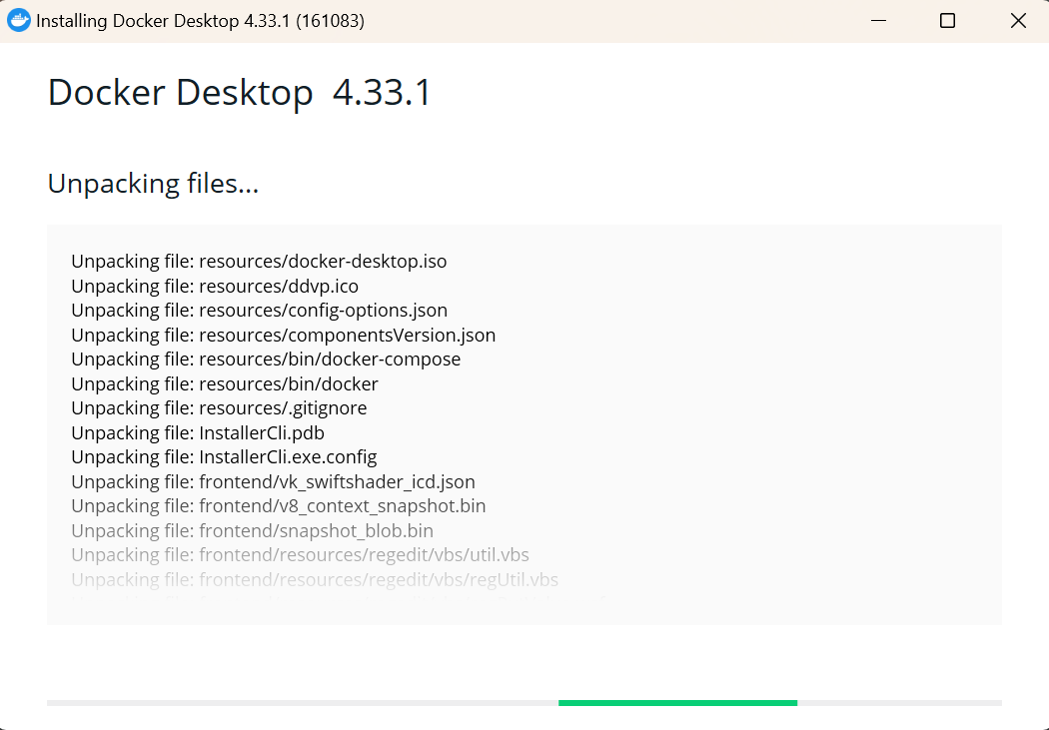

**Step 02:** Now go to command prompt and type ‘docker run hello-world’

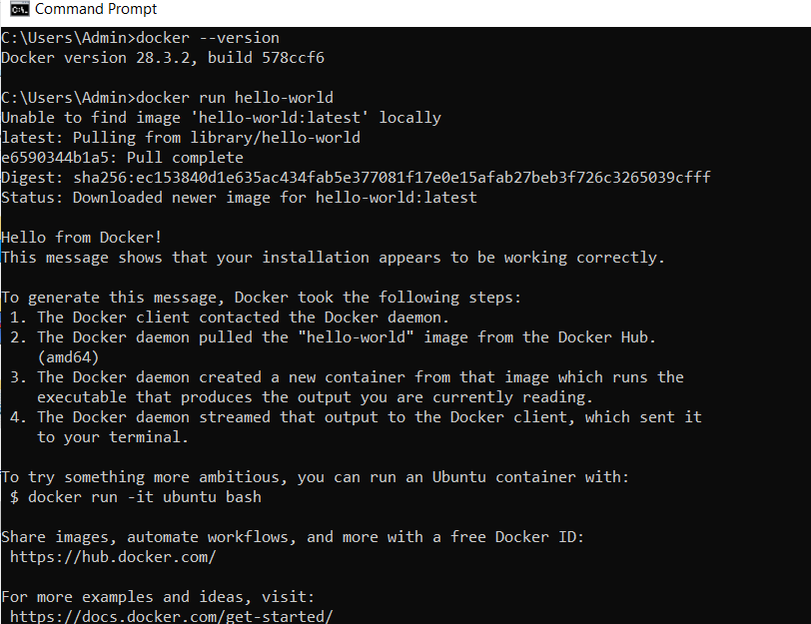

* Hello.c image is downloaded from: <https://github.com/docker-library/hello-world> for the source code of the hello binary included in this image

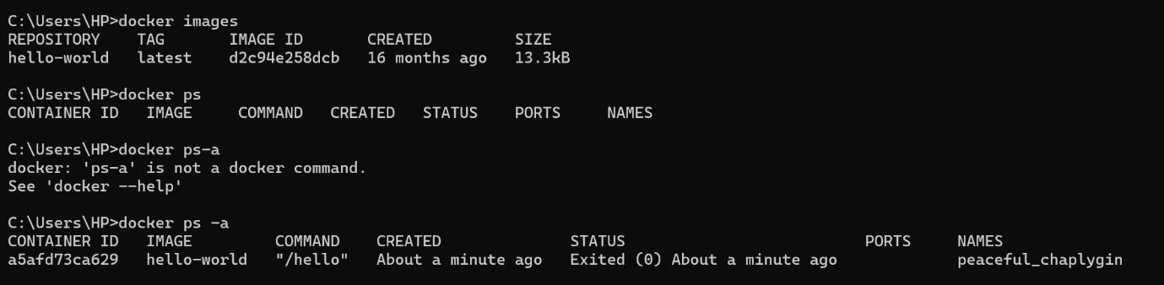

* docker ps
* docker ps -a: This command displays all images including exited running ones

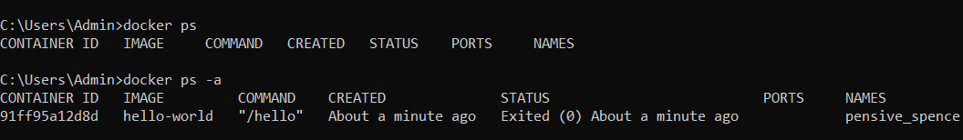

**Step 03:** Create an image & containerize it

* Open cmd and paste

*docker container create -I -t –-name mycontainer hello-world*



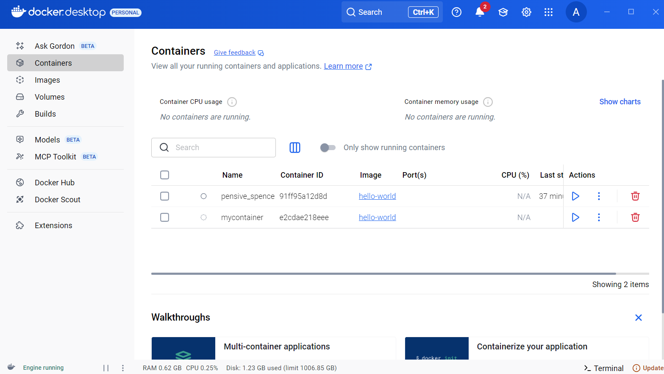

*docker container start –attach -i mycontainer*

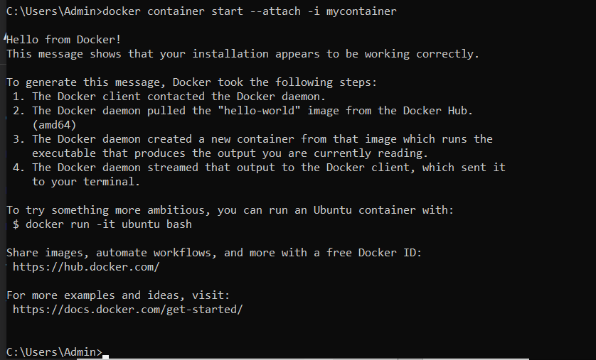

*docker pull hello-world*

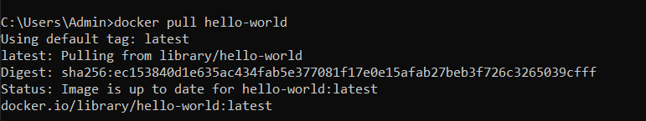

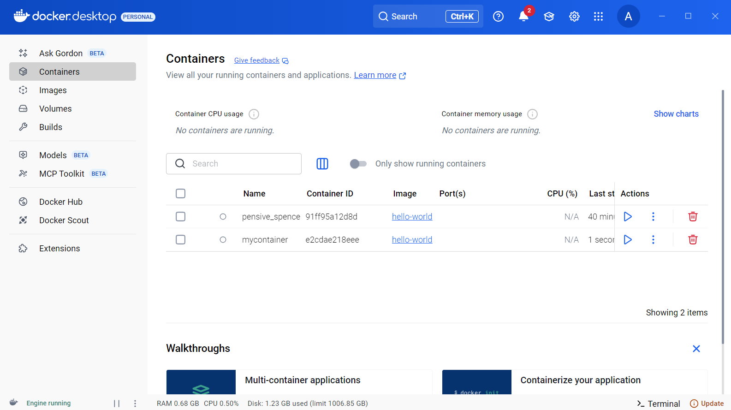

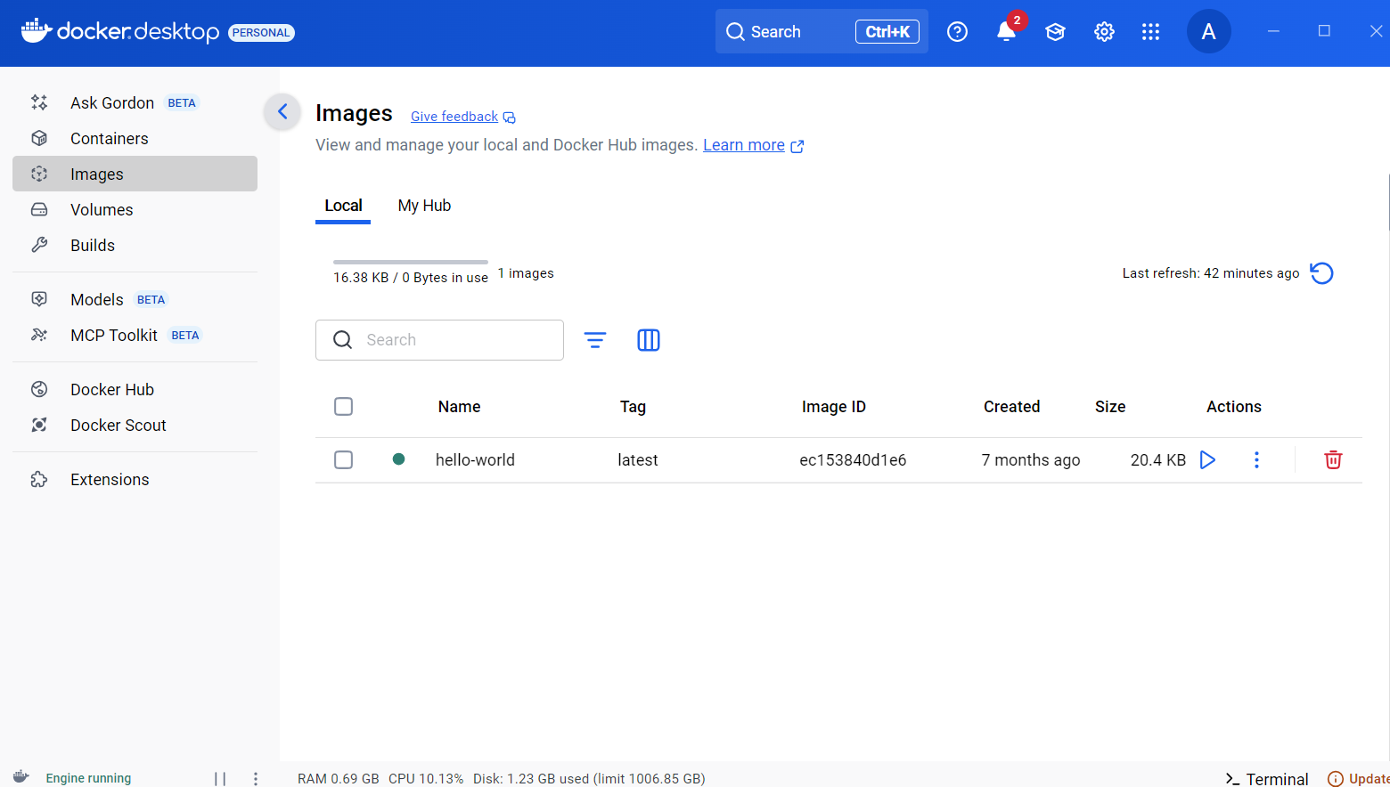

**Step 04:** Remove docker image

* *docker image rm hello-world*
* If image is running ‘*docker image rm hello-world -f’*

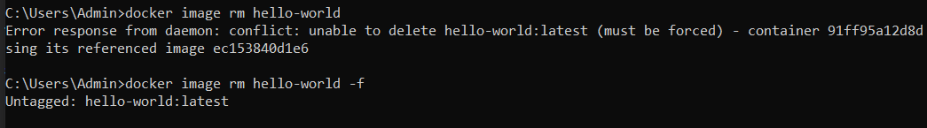

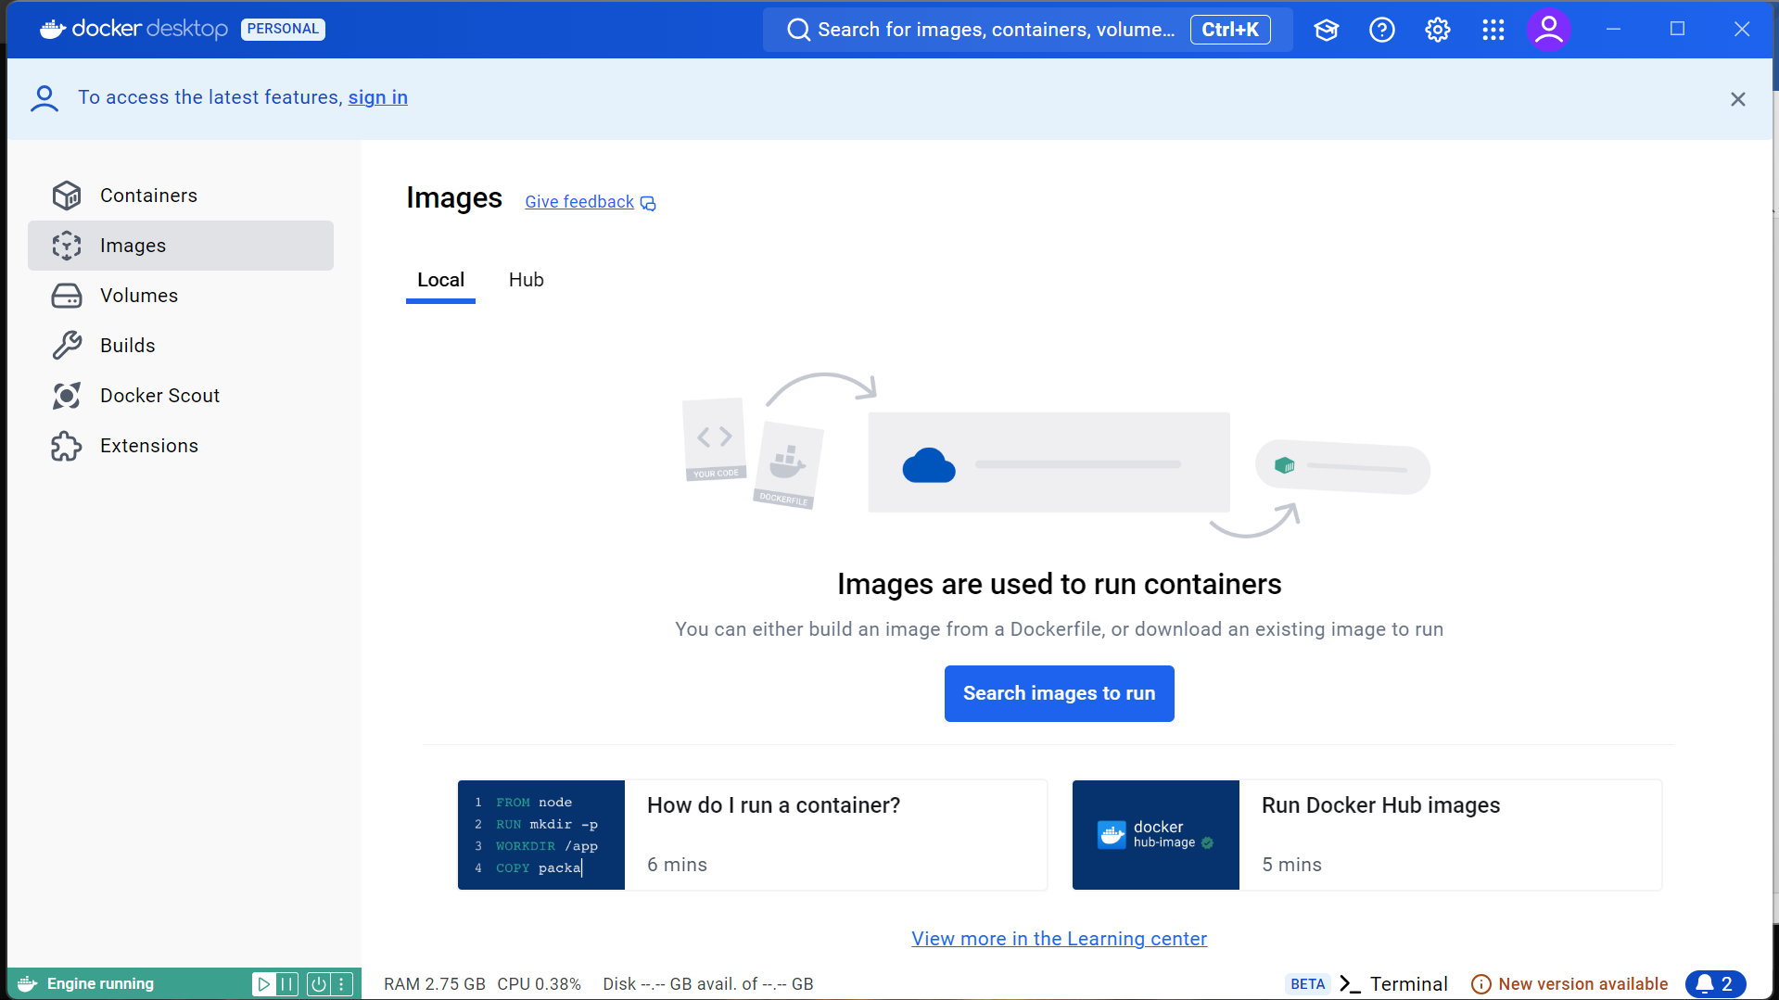

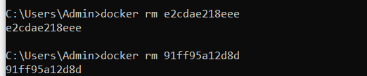

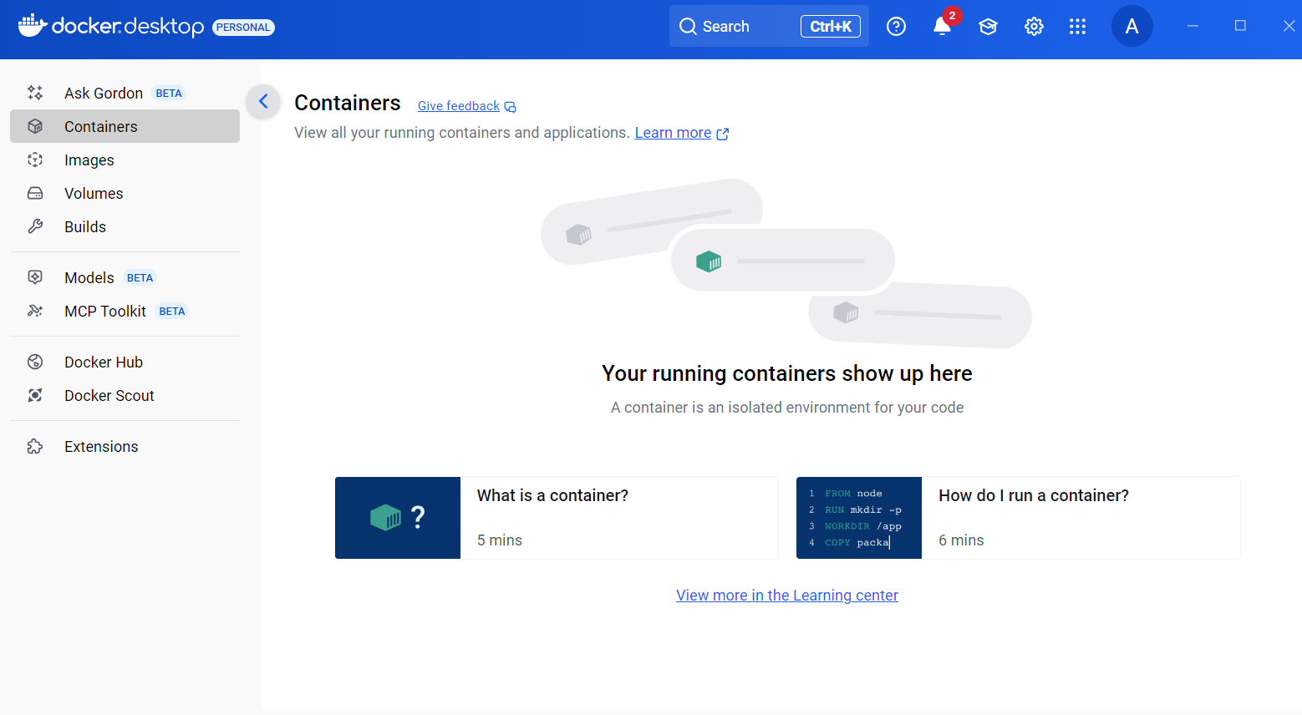

**Step 05:** Create an additional application (Python Data visualization)

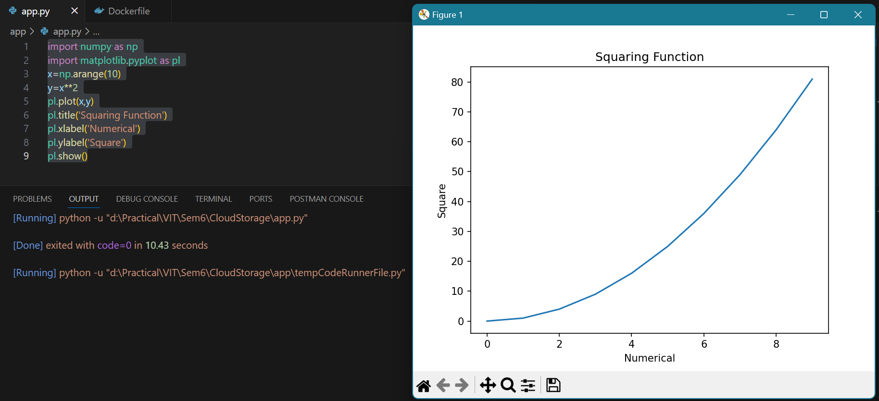

* Create a simple python app

*import numpy as np*

*import matplotlib.pyplot as pl*

*x=np.arange(10)*

*y=x**2*

*print(“This is the squaring function”)*

*print(x,y)*

*pl.plot(x,y)*

*pl.title('Squaring Function')*

*pl.xlabel('Numerical')*

*pl.ylabel('Square')*

*pl.show()*

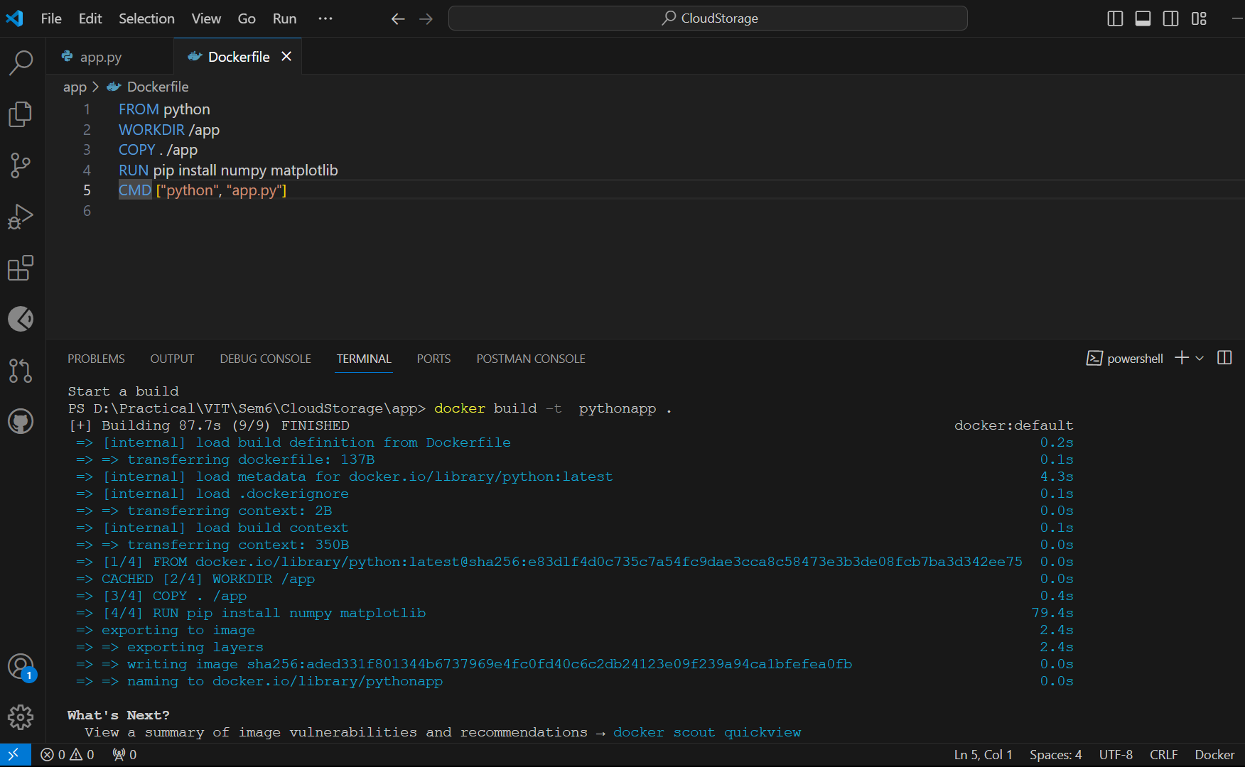

* Create a docker file and ensure to include RUN pip install ~library-name~

*FROM python*

*WORKDIR /app*

*COPY . /app*

*RUN pip install numpy matplotlib*

*CMD ["python", "app.py"]*

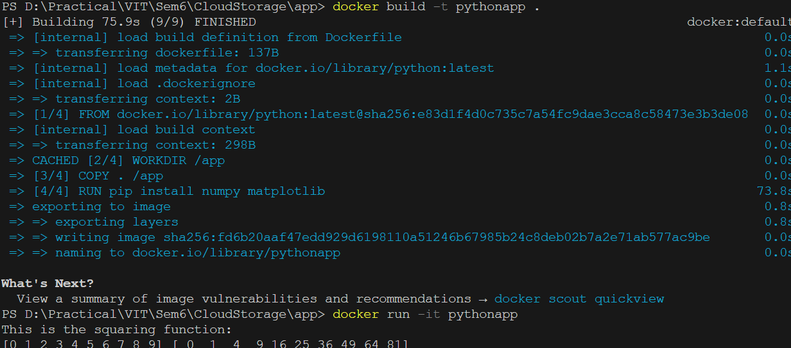

* Now open an integrated terminal by selecting the file from the opened folder. Right click and select open in integrated terminal.
* Type `*docker build -t pythonapp .*` or any other image name used for creation
* `*docker run -it pythonapp*`

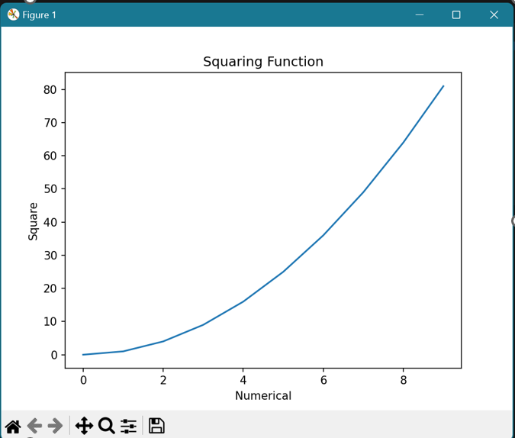

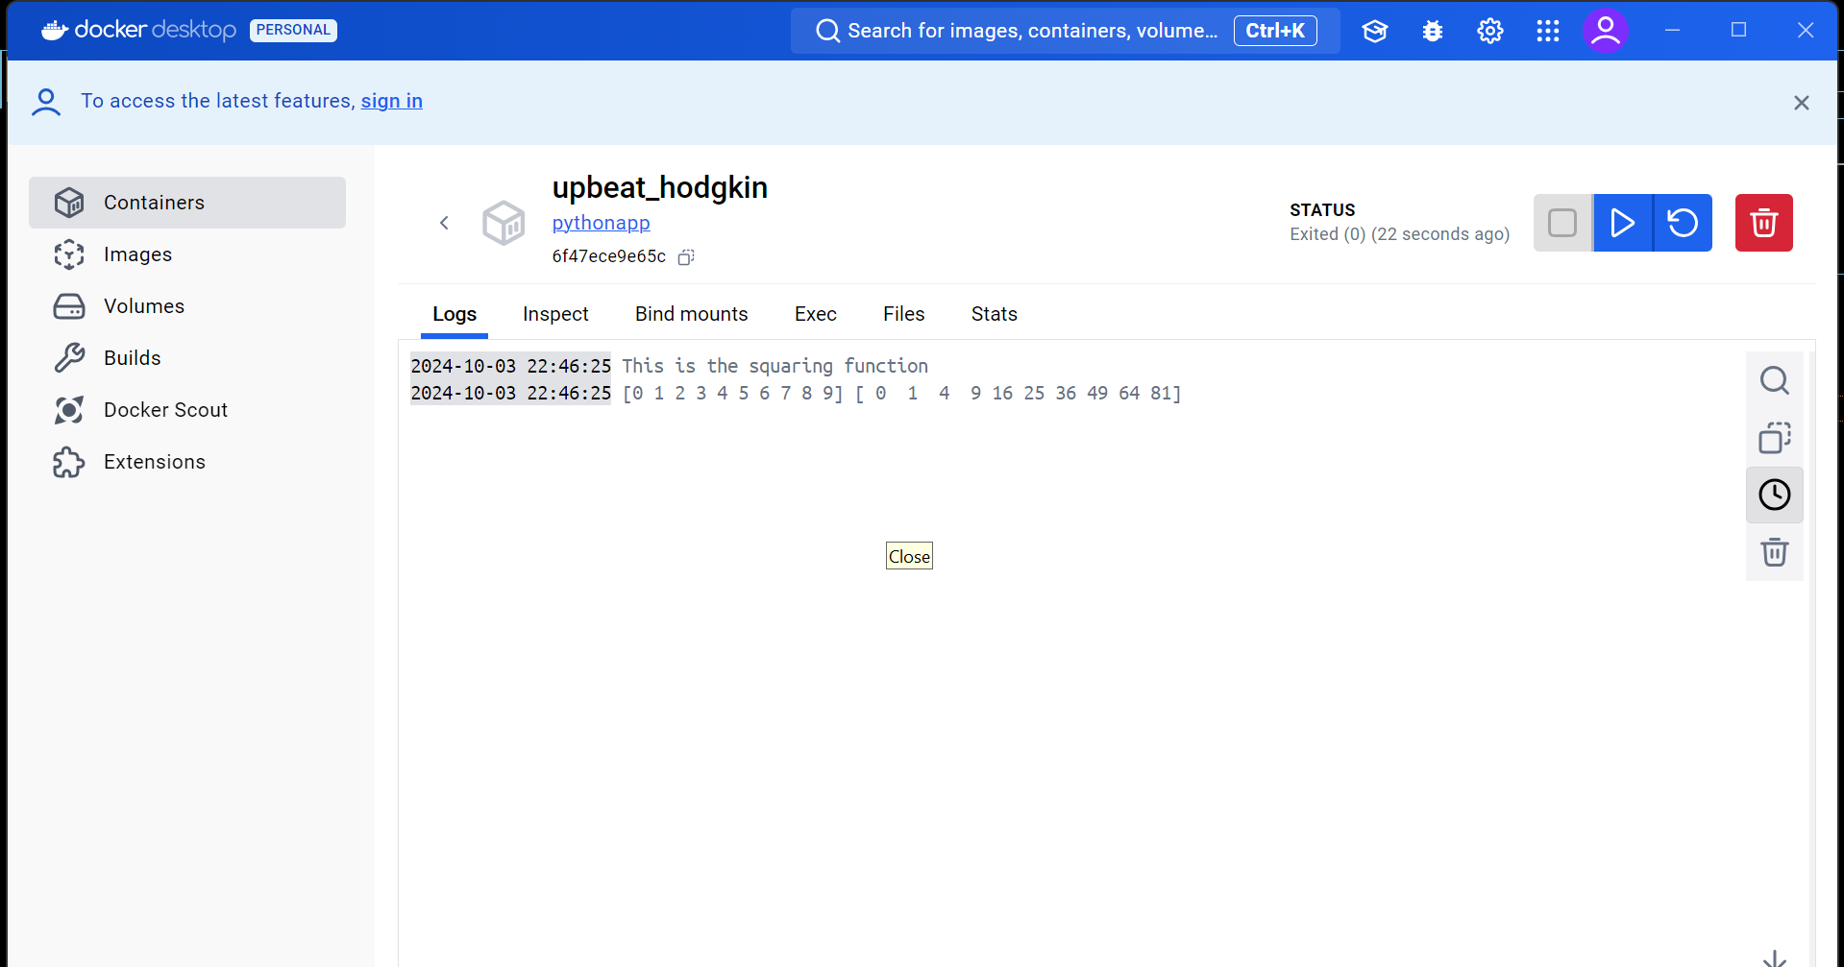

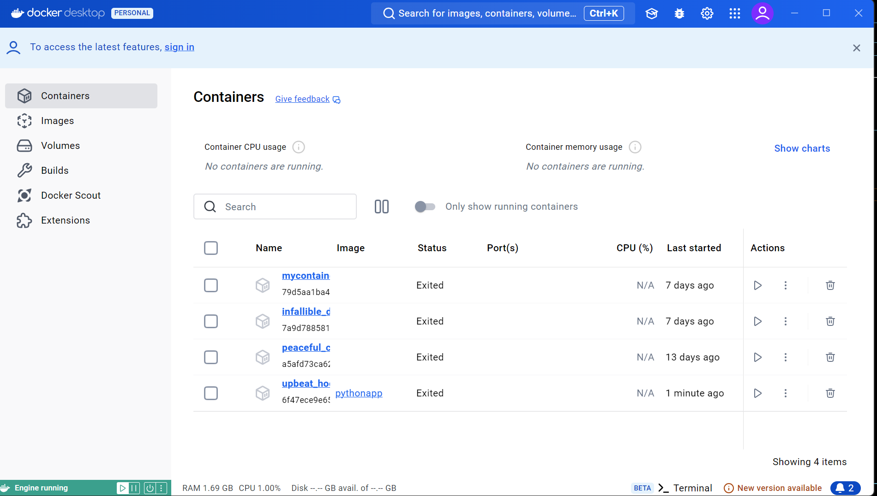

* Go to docker and run the file
* In cmd check all docker images

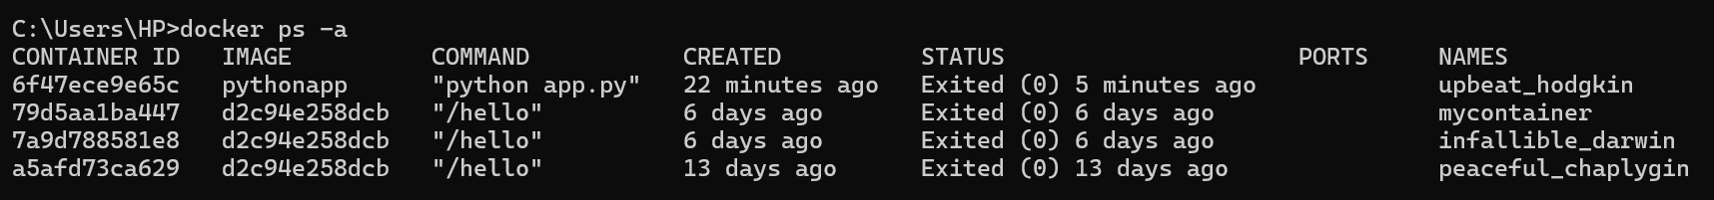

* After using docker images, remove the files using *‘docker image rm python -f’*